

HYPEREAL

Positioning System Open Source Docs– Hardware Part

|  |  |  |
| --- | --- | --- |
| Date | Modified by | Comments |
| 2017-02-10 | Hypereal | Init Version. |
|  |  |  |
|  |  |  |
|  |  |  |
|  |  |  |
|  |  |  |
|  |  |  |

1 Overview 3

2 Lighthouse 3

2.1 Laser Scanning Line Generator 4

2.2 Cylindrical Rotary Structure’s Position Feedback 4

2.3 Three-Phase Motor Drive Circuit 5

2.4 Laser Tube Driver 6

2.5 About Selection Of Motors 6

3 Positioning Device 8

3.1 Laser Sensor Analog Front-End 8

3.2 Digital Signal Processing And Caculation 8

3.3 Correction And Compensation Of Measurement Results 9

3.4 The Software Logic Of The Positioning Device 10

4 System Phase Synchronization Mechanism 12

# Overview

This document presents the overall structure, design, and implementation details of the hardware part of the Hypereal laser positioning system. Content involves circuits and embedded software. The components involved in the document are extracted from the Hypereal laser positioning system principle verification prototype. This document eliminates parts which have nothing to do with the positioning feature and can be considered to be the minimum system to implement laser positioning feature.

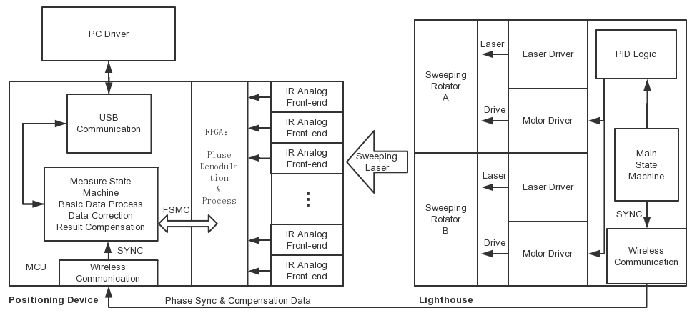

The overall structure of the system is divided into two relatively independent parts, respectively, laser scanner (called lighthouse) and positioning device (in this document to HMD as an example), will be described separately in the document.

# Lighthouse

Lighthouse is composed of MCU control, motor drive, laser drive, position feedback signal generation parts.

The main logical structure is as follows:



## Laser Scanning Line Generator

Lighthouse is the location reference of the whole positioning system. The basic principle is to produce two mutually perpendicular infrared laser sweep in space. The scanning angular velocity and phase is known by control logic and measure circuit in lighthouse, which means the very time when sensors are scanned can be calculated to the angle between current sensor positon and the point where the lighthouse is located in two vertical directions.

Single axis laser scanning line generating device is as follows, the laser module generates infrared light, shot into the cylindrical rotary structure. The structure is driven by three phase brushless motor. In the central axis of the cylindrical structure placed a reflector ,reflect the spot light into a lenticular lens which is fixed on the cylindrical surface of the rotating cylinder, and this lenticular lens converts the spot light into a laser scanning line parallel to the cylindrical rotary structure axis which sweeps the whole space.

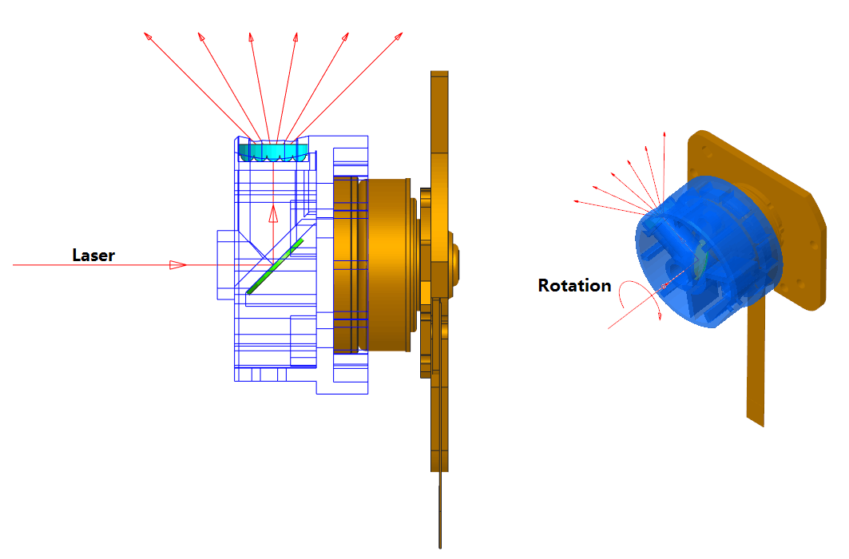

## Cylindrical Rotary Structure’s Position Feedback

A single lighthouse has two structures perpendicular to each other, defined as the scanning X-axis and the scanning Y-axis, respectively. In order for the signals to be classified as the two axes, the motors that drive the two axes need to be shifted 180 ° from each other to provide a theoretical 180 ° scan angle coverage. According to common sense, the motor rotation need to achieve closed-loop regulation. In order to achieve the above needs, we installed reflective strip on the barrel rotating structure, which work with the ir send / receive tube to obtain a position feedback signal once per turn. The actual working state of the system has achieved 3600RPM ± 200ppm rotation speed accuracy.

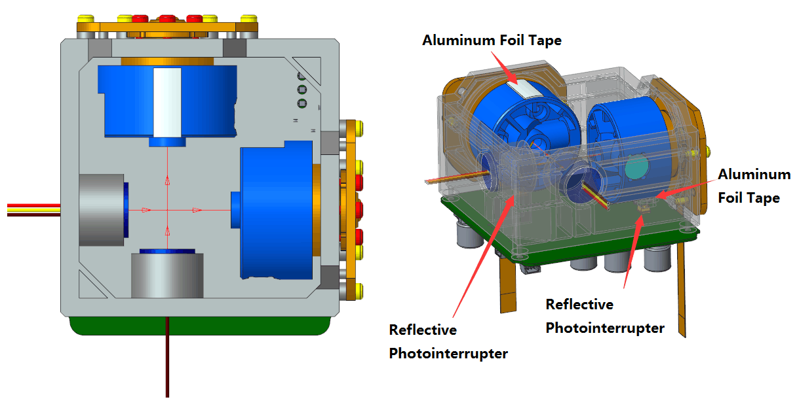

Considering of the optical path between lighthouse and the positioned device may be blocked by other objects (such as turning back when wearing HMD), the system requires at least two lighthouses. To solve the problem of optical path confliction of two lighthouses, second lighthouse still need to be synchronized to the previous lighthouse, and two lighthouses need to staggered generate laser. We actually make these two devices work in master/slave mode, the overall closed-loop as shown below:

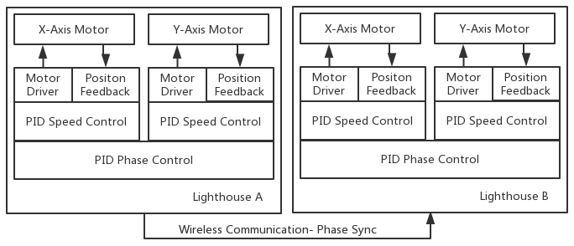



## Three-Phase Motor Drive Circuit

Lighthouse circuit is an embedded system based on STM32F103. The MCU maintains PID regulation, multi-loop coordination, and synchronization phase calculation process. The phase synchronization between the master and slave lighthouse is carried out by wireless communication. Three-phase motor drive part uses DRV10866S as driver IC, as shown below. The key point here is, on the issue of motor speed controlling, adjust the VCC drive voltage is significantly better than adjust the PWM payload which inputs to DRV10866. Because the motor drive chip logic clock resolution is not enough for the PWM signal duty cycle analysis calculation and this causes the sampling problem. Since the motor speed is constant in this application scenario, a cheap multi-order RC passive low-pass filter works fine here.

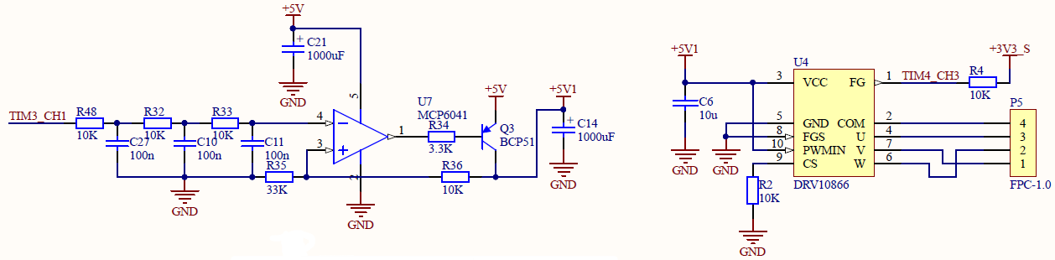



## Laser Tube Driver

In this scheme, the laser signal attenuates linearly with the distance between the positioning device and the lighthouse according to the theoretical calculation(in practice, the attenuation speed of light which passes a non-ideal lenticular lens is faster), and on the other hand, for the sake of security considering, it’s not allowed to use too strong laser. So, in order to distinguish between the scanning signal and the environment interference light (the positioning device is not ideal photosensitive components, such as fluorescent light source will be false triggering), we modulate emission laser by 2Mhz 50% duty cycle square wave signal. This part of the circuit is as follows:

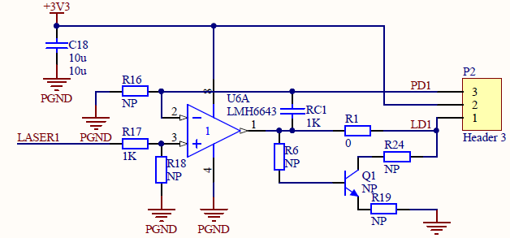

## About Selection Of Motors

To the premise of speed stability requirement under constant speed and constant load, the selection of the motor is the main factor. Selectable model which can achieve the accuracy of 200PPM speed jitter performance is not much. The important feature is whether it has hydraulic bearings and whether it’s external rotor brushless motor.

# Positioning Device

## Laser Sensor Analog Front-End

The premise of positioning is that the laser scanning line can be converted to an electric signal for digital processing. We use BPW34 silicon photovoltaic cells as a photosensitive device, the analog front-end is a classic photoelectric current transimpedance amplifier circuit cascade voltage gain structure, the last stage is designed as a hysteresis comparator. Amplifier OPA2836 appears to be a suitable choice for the post-digital processing. The choice is limited by bandwidth, size constraints and the requirements of restoring 2Mhz modulated optical signal. At the same time, the matching of BPW34 equivalent capacitance and transimpedance is also noteworthy.

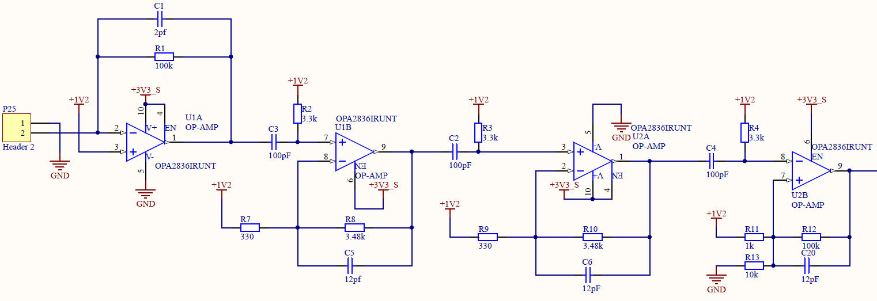

## Digital Signal Processing And Calculation

The analog front-end output signal as shown below, is a set of square wave signal. The main part is expected 2Mhz signal, with irregular distortion on the head and end.

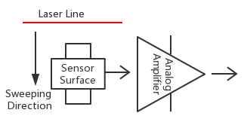

Useful Part

We need to quantify this pulse sequence to a moment as a parameter in the calculation. However, according to the obvious principle, the length of this pulse will change with the distance between the lighthouse and positioning device, then measure the moment based on the principle becomes ambiguous. Our method is to remove the pluses where the period does not meet the expected 500ns ± a certain threshold time, taking the time midpoint of the pulse sequence as the calculation base. Through practical verification, this approach is reasonable.

Define t0 is the moment when the angle of the motor is over 0°. According to the principle of measurement, the angle of the sensing point relative to the rotation axis of the motor can be deduced as follows:

$$θ=\frac{\left(t1-t0\right)×ω}{2π}×360°$$

In fact, the angle calculation of the positioning point is carried out on positioning device. Considering the real-time problem (analysing the pulse in real time), we need to calculate multiple channels locating points at the same time. So we place a Cyclone4 FPGA as coprocessor with STM32F4 MCU in the digital system.



FPGA is responsible for dealing with the basic counting and triggering of the pulse sequence (Sensor channels can be up to 30-40), and do basic analysis. When a scan cycle ends, MCU read measurement results register through FSMC bus, then process calculation and maintain data communication with PC through USB.

## Correction And Compensation Of Measurement Results

For this measurement system, there are plenty sources of error, such as eccentric, off-axis, XY axis is not vertical and so on. In the hardware system firmware level, error’s main part can be corrected by motor speed and phase offset compensation.

Speed ​​and phase offset are almost no way to avoid, depending on the problem of motor precision. Speed ​​error is about an unpredictable tiny value. However, the compensation of this part is better than nothing. Phase deviation refers to the current target phase and the actual phase difference, it can be understood as the integral value of speed error in a nominal period. According to our test data, it’s about a fluctuation in several seconds period.

Our approach is that the beacon observed these two values ​​and send them with synchronization signals (described in detail later) together through the wireless channel to the positioning device. Correction calculation proceeds in positioning device’s MCU. Calculation formula in section 3.2 will be corrected as:

$$θ=\frac{\left(t1-t0\right)×(ω+∆ω)-∆∅}{2π}×360°$$

After correction, the measurement results can be stabilized within the range of 2.5us.

## The Software Logic Of The Positioning Device

As the synchronization signal transmission requires a very high real-time feature. Interrupt mutex and Flag-Poll state machine are used in microcontroller firmware. First of all, timing synchronization is essential to ensure that wireless data interrupt and other interrupt system does not overlap. Secondly, to tasks do not have strict real-time requirements, in order to reduce the time taken up by the interrupt, firmware is generally not process procedure directly in interrupt area. But only set flags in interrupt and poll the flag state in the main program to deal with the task quest.

Following is a measurement process as an example:

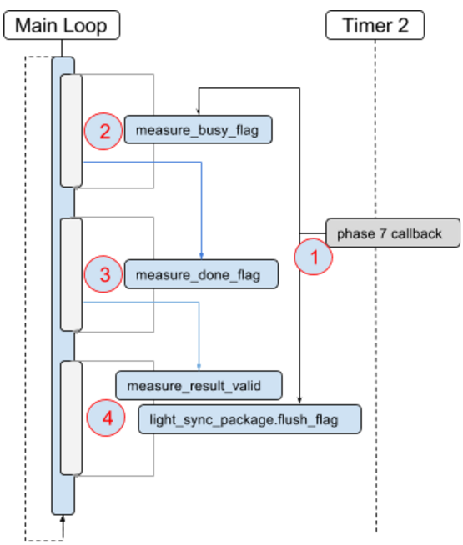

1. When the measurement cycle into the appropriate phase, enable the FPGA to start measuring of lightsensors in the callback function, and set the measure_busy_flag and light_sync_package [1] .flush_flag (omit several conditional judgments here), indicates a new lighthouse synchronization packet arrived, and FPGA measurement is proceeding;
2. When the main loop poll FPGA detects that the flag measure_done_flag has been set, it reads the FPGA measurement data and sets the flag measure_done_flag after reading all the fpga measurement data to indicate that the FPGA measurement data has been read;
3. The main loop polling flag measure_done_flag, if set to save the FPGA measurement data, then set flag measure_result_valid, indicate FPGA measurement data has been saved, ready to send;
4. The main loop polling flag: light_sync_package [1] .flush_flag and measure_result_valid, if set, return the measured result data via USB.

# System Phase Synchronization Mechanism

According to the above, in this system, the lighthouse needs to send the synchronization signal to synchronize devices at specific time as the time reference point of the calculation. Each measure cycle is 1/30 second (≈33.33ms). Time base is the internal crystal clock of lighthouse A, and the starting time of lighthouse a synchronization signal data packet is defined as the start of a measurement period. Other devices derives the transmission time window at the time of receiving the synchronization signal packet. Lighthouse A synchronization signal packet strictly in its own crystal as 1/30 second cycle repeat. The overall logic timing is as follows:

|  |  |  |  |  |  |
| --- | --- | --- | --- | --- | --- |
| Time(ms) | 0 | 8.33 | 16.67 | 24 | 33.33 |
| Phase(°) | 0 | 180 | 360 | 540 | 720 |
| LH A-X Axis | Sweep | - | - | - | Sweep |
| LH A-Y Axis | - | Sweep | - | - | - |
| LH B-X Axis | - | - | Sweep | - | - |
| LH B-Y Axis | - | - | - | Sweep | - |

Sweep interval in the table logically coincide with the 180° scan window of scan axis motor-driven laser tube. The measured state machine of positioning device is driven by synchronization signal packet, and the measurement results of the respective axes are obtained in sequence.

According to section 3.3, the actual phase of the lighthouse cannot completely coincide with the 1/30 second period. The wireless synchronization signal from the lighthouse contains both the shaft position compensation information and the speed compensation information. The synchronization package is defined as follows:

|  |  |  |  |  |  |  |  |  |  |
| --- | --- | --- | --- | --- | --- | --- | --- | --- | --- |
| Byte Num | 0 | | 1 | | 2 | 3 | 4 | 5 | 6 |
| Bit domain | 1bit | 7bit | 1bit | 7bit | 8bit | 8bit | 4bit+4bit | 8bit | 8bit |
| Bit definition | ID1 | COMP_X | RESV | COMP_Y | D_XH | D_YH | [D_XL,D_YL] | VER | SCAN_NUM |

Bit segment definition Description:

|  |  |
| --- | --- |
| ID1 | 1’b0: Lighthouse A send  1’b1: Lighthouse B send |
| COMP_X | 7bit signed integer number, this indicates that the current lighthouse X-axis motor speed.  Calculation period: Period = (20000 + COMP) * ( 1/60) seconds |
| COMP_Y | 7bit signed integer number, this indicates that the current lighthouse Y-axis motor speed.  Calculation period: Period = (20000 + COMP) * ( 1/60) seconds |
| [D_XH,D_XL] | 12bit signed integer number representing lighthouse X-axis offset  Unit: 1/60/20000 seconds |
| [D_YH,D_YL] | 12bit signed integer number representing lighthouse Y-axis offset  Unit: 1/60/20000 seconds |
| VER | 8bit unsigned integer number, indicating the version of the lighthouse |
| SEND_CNT | 8bit unsigned integer, plus one when a full measurement cycle is proceeded |